**AstroSage Analysis**



By Naveen Kumar

**Problem Statement :-**

AstroSage has received a 1 crore investment and aims to optimize its call center operations. The goal is to determine how to allocate this investment to maximize operational efficiency, customer satisfaction, and profitability. The analysis will consider historical call data, performance metrics, and market trends to make informed decisions.

**AstroSage Dataset**

The AstroSage Dataset consists of these columns:

* **_id:** Unique identifier for each record.
* **user:** User ID associated with the record.
* **chat Status:** Status of the chat (ex. Completed, incomplete, failed, pending, started)
* **guru:** Profile ID of guru
* **guruName:** Name of the guru
* **gid:** Unique guru ID.
* **uid:** Unique user ID.
* **consultation Type:** Type of consultation (ex. Call, Chat, Live Public calls, Complimentary).
* **website:** Source of the contact or consultation (ex. App, gurucool website).
* **Refund Status:** Indicates if the session is refundable or not (ex. Refunded, no-refund, Processing).
* **is WhiteList User:** Boolean indication of the user is whitelisted.
* **chat Seconds:** Duration of the chat in seconds.
* **queue:** Boolean indication if the session was queued.
* **FreeCall:** Indicating that whether the call service was free or paid.
* **Free Chat:** Indicating that whether the chat service was free or paid.
* **CreatedAT:** Status of creation date and time.
* **updatedAt:** Status of update date and time.
* **v:** Review Version key.
* **statementEntryId:** Identifier for the statement entry.
* **chatStartTime:** Start time of the chat.
* **chatEndTime:** End time of the chat.
* **timeDuration:** Duration of the chat session.
* **callChannel:** Channel used for the call.
* **callIvrType:** VR type used for the call.
* **callStatus:** Status of the call.
* **CallSid:** Unique identifier for the call session.
* **amount:** Amount charged for the session.
* **astrologerCallStatus:** Status of the astrologer for the call.
* **astrologerOnCallDuration:** Call duration of the astrologer.
* **astrologersEarnings:** Earnings of the astrologer from the session.
* **netAmount:** Net amount after deductions.
* **region:** Region of the user.
* **userCallStatus:** Status of the user's call.
* **userOnCallDuration:** Duration of the user's call.
* **rating:** Rating based on the session from the User

**TASKS**

**Objective Questions:**

**1**.What is the total no. of tables present in the data?

Ans: Only 1 table is given and present in the dataset for analysis.

**2**. What is the total no. of attributes present in the data?

Ans: There are 35 attributes / columns in the data and post cleaning up there are 40 columns which I have used for generating Dashboards by extracting the date & time columns.

**3**. The data consists of some inconsistent and missing values so ensure that the data used for further analysis is cleaned.

Ans: Data has been cleaned up by filling the blank values with the help of different filters, Text functions, Conditional formatting, Condition aggregations, Format functions, Date & Time functions.

If chat status is blank and consultation type is call then filled the chat status blank values based on the N/A.

**4.** What is the change in daily call volume day by day and also find the average daily call volume.

Ans:

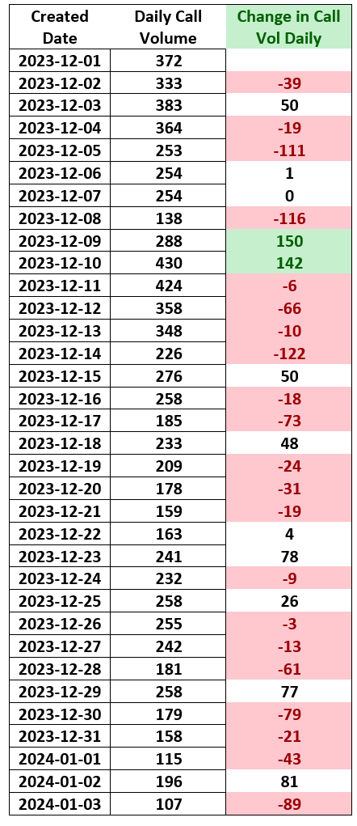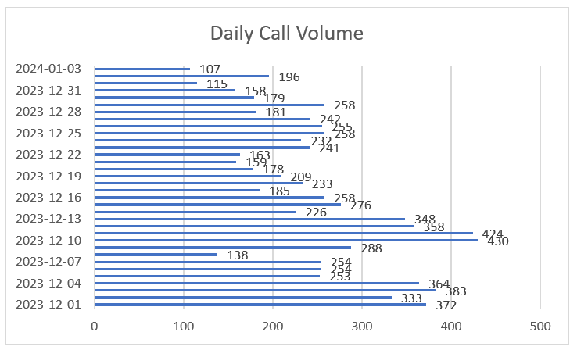

**5.** Which months experienced the highest and lowest call volumes?

Ans: December month has experienced highest call volumes 31 days of data (In total 8090) January month has experienced lowest call volumes as we have only 3 data of data (In total 418) Highest December Month – Max (Highest) - 430

Lowest January Month – Min (Lowest) – 107

**6.** What is the total operational cost for that month?

Ans: Total Operational cost for December = 108428.46 Total Operational cost for January = 6412.82

Calculation Operational Cost = Sum of netAmount – Sum of astrologersEarnings

|  |  |  |  |
| --- | --- | --- | --- |
| December  month |  |  |  |
| Row Labels | Sum of netAmount | Sum of astrologersEarnings | operational cost |
| Call | 159875.6183 | 73925.84317 | 85949.77517 |
| Chat | 42288.41 | 19851.83017 | 22436.57983 |
| Complimentary | 0 | 0 | 0 |
| public_live_Call | 50.597 | 8.489616667 | 42.10738333 |
| Grand Total | 202214.6253 | 93786.16295 | 108428.4624 |
|  |  |  |  |
| January month |  |  |  |
| Row Labels | Sum of netAmount | Sum of astrologersEarnings | operational cost |
| Call | 8566.416667 | 3873.596667 | 4692.82 |
| Chat | 3206.273333 | 1486.811333 | 1719.462 |
| Grand Total | 11772.69 | 5360.408 | 6412.282 |

**7.** What is the average number of calls handled per agent per day?

Ans:

Total Calls received = 8508 including failed

Total Astro Guru’s = 131 (Count of guru_unique_id)

Total no. of days = 34

Average no. of calls handled by each guru = Total Calls received / Total Astro Guru’s

=8508/131 = 64.95

Total no. of Call handled by Guru per day = Average no. of calls handled by each guru / Total no. of days = 64.95/34 = 1.92

Round of 1.92 is 2.

On an average the calls handled by Guru per day is 2 approx.

**8.** How many repeat callers are there, and what percentage of total calls do they represent?

Ans: Repeated Calls are calculated as how many repeated calls differentiate to how many users called repeatedly is divided by Total no. of Users called

Total no. of users = count(unique_id) = 28027

Total No. of Repeated Calls by users = sumif(user_profile_id(column), “>1”) = 19879

Total no. of Users called = Single Team Calls = count(Total Connections – Repeated calls) = 3629 Total Connections = count(unique_id)

Repeated Calls = sumif(user_profile_id(column), “>1”)

Total no. Callers = no. of users who used call option = count(users_unique_id) Overall Repeat Callers % = (((19879 – 3629)/28027)*100)

Overall Repeat Callers % = 57.97% Which is approx. 58%

|  |  |
| --- | --- |
| Attributes | Values |
| Total Connections | 28027 |
| Repeated Calls | 19879 |
| Single time calls | 8148 |
| Total no. of Callers | 3629 |
| Overall % of Repeated calls | 58% |

**9.** What are the total sales generated by the call centre for each product category?

Ans: Total Sales generated by each product category gurucool = 20225 = 72%

app = 7800 = 28%

dashboard = 2 = 0.000071%

|  |  |
| --- | --- |
| Website | Count of Website |
| app | 7800 |
| dashboard | 2 |
| gurucool | 20225 |
| Grand Total | 28027 |

**10.**How many calls were made for each user ID and guru ID?

Ans: : Total no. of Users called = Single Team Calls = count(Total Connections – Repeated calls) = 3629

Calls were made by each User

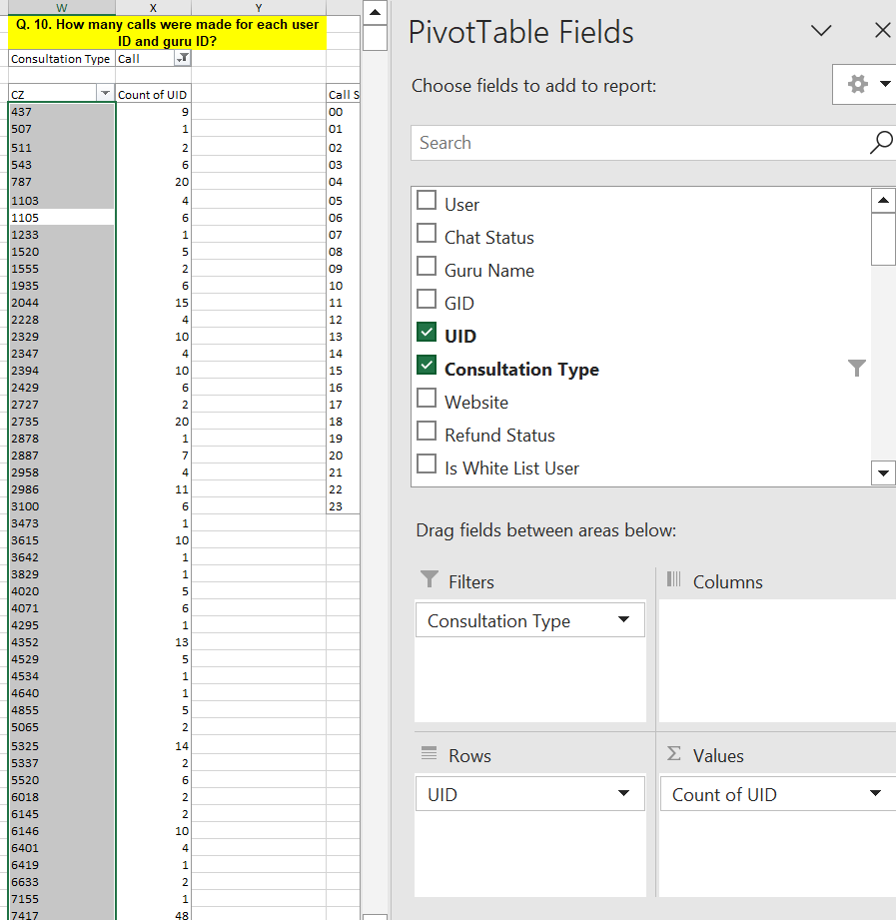

Calls were made by each Astro guru

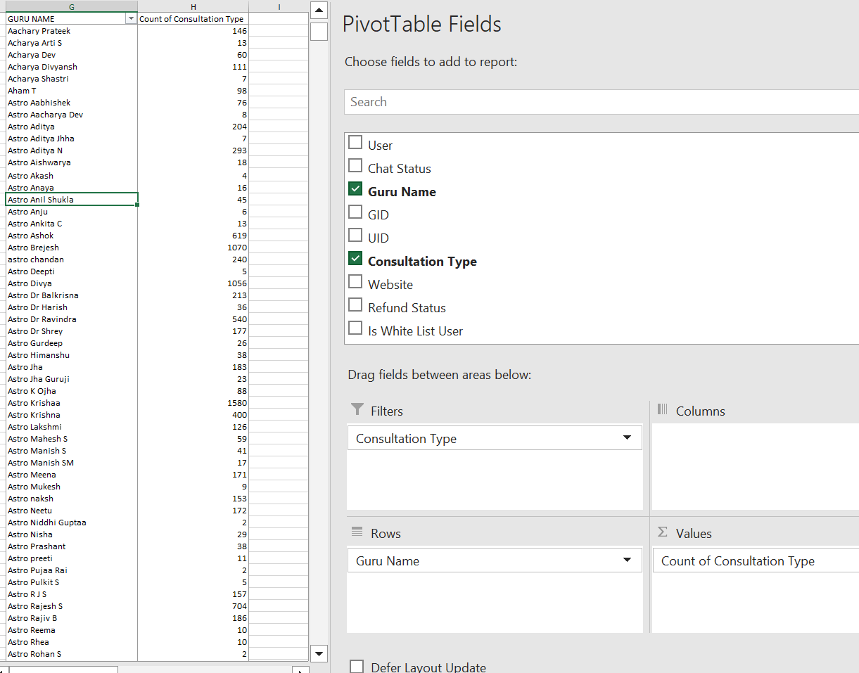

**11.** What is the correlation between call duration and customer satisfaction?

Ans: : =correl(userOnCallDuration, rating)

= 0.26

Which means it is having no meaningful relationship between the call duration and customer satisfaction. It should be at least 0.9 to having a correlation where is shows the dependency between the two factors.

**12.** Which guru has the highest and lowest customer satisfaction scores?

Ans: Highest Guru Satisfaction score = On overall Astro Krishaa received “8” rating which is

highest rating 169 times

Lowest Guru Satisfaction score = On overall Astro Yogendra received “0” Rating which is lowest

1. times

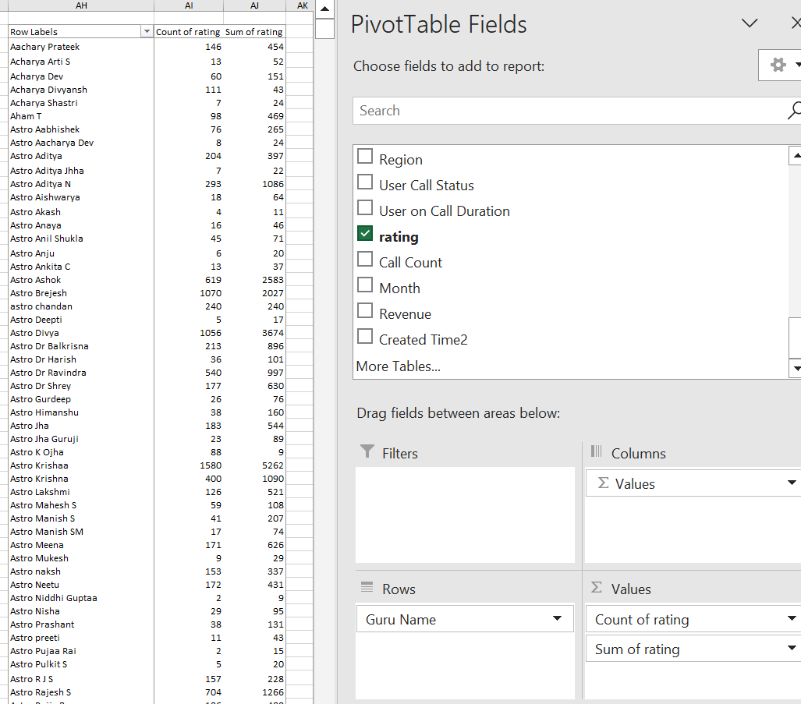

**13.** What is the average customer satisfaction score by month?

Ans: Average Customer Satisfaction score in December = 3.75

Average Customer Satisfaction score in January = 2.52

**14**. How many categorical columns are there in the data? [Search about categorical and continuous data, and try to answer this question]?

Ans: **Categorical Columns** – it represents the attributes contains categories or groups. It represents the non-numeric values, groups, labels like Region, Guru names & id, Profile ids, chat, call channels, consultation type, chat status, source, refund status, queue, freechat, queue, website

Note: ID will be considered under Categorical attributes like it will be not used for any aggregations so mentioned under the Categorical column.

**Continuous data** – it represents the attributes like Session duration, oncallduration, earnings, dates, chat seconds, chat times, net amount, rating.

**Note**: As these values can be aggregated for the calculations which shows the values of net amount, revenue etc which is continuous as it will provide the insights for the organization to calculate the values across the attributes.

**Subjective Question:**

**1.** Should the investment be used to hire more agents, improve training programs, or upgrade call center technology?

Ans: Yes, the investment should be parted in to different ways as we need to ensure the business will grow up.

* 1. Hire more Agents

Total Astro guru’s = 131

On an average the calls received per day is 250 used Average function for calculate the average

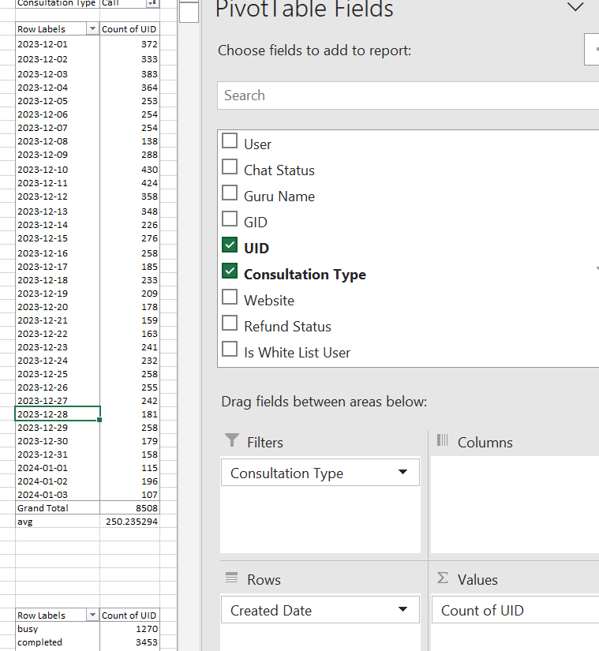

Whereas if we check the scenarios such as completed, busy, failed, not answered etc. then

|  |  |
| --- | --- |
| Row Labels | Count of UID |
| busy | 1342 |
| completed | 9172 |
| failed | 377 |
| N/A | 11769 |
| no-answer | 5367 |
| Grand Total | 28027 |

If we are checking the completed calls scenario then

% of completed calls = ((Completed calls / Grand Total of calls)*100) = ((9172 / 28027)*100)

= 32.72%

In total out of 250 calls on an average only 32.72% calls are getting completed around 113 calls are completed and rest are either failed or busy or no-answer.

To overcome this, we definitely need a part of investment to increase the work force by adding the Guru agents to provide the service for the customer.

**B**. Improve Training Program:

Training program is required based on the average session or call duration and rating of the guru provided for the session by Users.

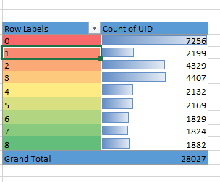

As we can see that the Users gave the rating where large number of Users (20323) out of 28027 in total provided the rating showing their satisfaction / dissatisfaction with the session.

Total Users = 28027

Total Users ratings submitted (for 0, 1, 2, 3, 4) =20323 = 72.51%

Total Users ratings submitted (for 5, 6, 7, 8) = 7704 = 27.4%

After analyzing this above data based on ratings, we can see that around 27.4% were satisfied with the ratings which are par above than usual or average rating and the rest 72.51% were gave their rating 4 or below 4 which below par

* After considering these ratings we have to invest in more Astro Guru who will be taking the session for Users to provide their queries by recruiting the new senior Astro Guru who is having a vast knowledge
* It will improve the time efficiency where the Astro’s can connect with the Users by overcoming the scenarios like failed or busy as they are busy in dealing with the other Users.

**C.** Upgrade Call Centre Technology:

As Call centre Technology need to be upgraded as currently, they are having Exotel as call service option where we can see the attributes like some calls are not getting connected. As this is concerned, we can have more call service options or we can upgrade the Exotel service or can look for other alternate services or we can include other alternative services by making this hybrid by having both Exotel and other call services which can increase the robust services by offering features like better integration, superior customer support, and enhanced voice quality, making them suitable for businesses seeking a more powerful communication solution

|  |  |  |
| --- | --- | --- |
| Count of UID | Column Labels |  |
| Row Labels | Exotel | Grand Total |
| busy | 1270 | 1270 |
| completed | 3450 | 3450 |
| failed | 1040 | 1040 |
| incomplete | 875 | 875 |
| no-answer | 1727 | 1727 |
| Grand Total | 8362 | 8362 |

We can start introducing the chatbots for the suggestions/ replies for the users who can use up to some extent by providing

some basic information.

Out of 8362 only 3450 which is around 41% was in completed status rest all lying under the incomplete statu

**2.** What are the potential risks of each investment option (hiring, training, technology upgrades), and how can they be mitigated?

Name the chart/spreadsheet function you will use for solving the problem.

Ans:

|  |  |  |  |
| --- | --- | --- | --- |
| **Option** | **Potential Risk** | **Mitigation** | **Chart/Function** |
| Hiring | On boarding costs, Overstaffing, | Use forecasted call volumes | TRENDLINE, AVERAGE. |
| Training | if agent churn or attrition is high then Retention incentives should be provided to retain them post training completion | Retention incentives | AVERAGE rating vs training hours |
| Technology upgrades | Costly, underutilized features, technology staff for operating & Monitoring | Chatbot implementation | COUNT of failures |

**3.** How does AstroSage's call center performance compare to AstroGuru's average call volume, customer satisfaction, and agent performance? Will you use any aggregation function or a visualization here to solve the problem?

Ans:



Total Calls received = 8508 including failed

Total Astro Guru’s = 131 (Count of guru_unique_id)

Total no. of days = 34

Average no. of calls handled by each guru = Total Calls received / Total Astro Guru’s

=8508/131 = 64.95

Total no. of Call handled by Guru per day = Average no. of calls handled by each guru / Total no. of days = 64.95/34 = 1.92

Round of 1.92 is 2.

On an average the calls handled by Guru per day is 2 approx.

|  |  |  |  |
| --- | --- | --- | --- |
| Count of UID | Column Labels |  |  |
| Row Labels | Exotel | N/A | Grand Total |
| busy | 1270 |  | 1270 |
| completed | 3449 | 1 | 3450 |
| failed | 1040 | 145 | 1185 |
| incomplete | 875 |  | 875 |
| no-answer | 1726 | 2 | 1728 |
| Grand Total | 8360 | 148 | 8508 |

Out of 8508 total calls only 3450 calls are getting completed, which is 40.55 %. It means around 59.45% users are not getting the service irrespective of booking that happened by having the rating as 3.5 for the call option.

|  |  |
| --- | --- |
| Row Labels | Average of rating |
| Call | 3.500940291 |
| Chat | 2.687557651 |
| Complementary | 4.5 |
| public_live_Call | 3 |
| Grand Total | 2.93463446 |

And the most revenue is generated from Calls only. So, if Call service is going well and all the bookings are being completed then we can see more increase in the earnings and revenue.

|  |  |  |  |
| --- | --- | --- | --- |
| Row Labels | Average of rating | Sum of Net Amount | Sum of Astrologers Earnings |
| Call | 3.500940291 | 168442.035 | 77799.43983 |
| Chat | 2.687557651 | 45494.68333 | 21338.6415 |
| Complementary | 4.5 | 0 | 0 |
| public_live_Call | 3 | 50.597 | 8.489616667 |
| Grand Total | 2.93463446 | 213987.3153 | 99146.57095 |

Approximately 78.71% of net amount is coming from Calls only.

Percentage of call income = ((Sum of net amount from call / Total net amount) *100)

As Operational cost there is a correlation between the agent earning and net amount because if the net amount is directly proportional to the agent earning.

A correlation of 0.995 suggests that very strong positive linear relationship between the two variables. This means that as one variable increases, then the other variable will increase automatically in a similar predictable pattern.

**4.**How can the call center improve its handling of peak call periods to ensure high customer satisfaction? Mention the functionality you will use for giving the suggestions, will it be any aggregated function or a visualization?

Ans:

As we can see that on 10 December 2023 and 11 December 2023 recording most no. of calls irrespective of

the status of the calls.

On the day where we have seen the highest number of calls recorded around 45% of calls were completed

rest all are failed, Busy, Incomplete etc.

In this way we can analyze and take the actions accordingly

* Hiring / Recruiting – Based on the peak timings whenever recruitment happens mention the working hours and ask them to be available during the peak hours by assigning the work shifts.
* This Company can conduct the weekly sessions with wider audience to engage them

with the Astro Guru’s to connect with separately.

* More agents can be asked to be available during the peak hours by assigning them to shifts to give the sessions accordingly to the users to avoid the incomplete status of the calls or chats.

**5.**Based on historical data, what strategic initiatives should be prioritized to improve efficiency and customer satisfaction?

Ans:

* Technology can be upgraded by having AI chatbots by providing the services based in the users reply and traffic tools can be used to monitor by assisting the users to schedule the sessions accordingly based on the sessions already booked by the users.
* Trail session can be scheduled for users for free to engage them in and can be given some discount schemes or introducing the memberships plans for the users to neglect the churn rates.
* If the Astro Guru’s response is clear then the Users will be giving the good rating which eventually increases the satisfaction which will be resulting in the net amount for the completion of the sessions.
* More Astro Guru’s can be hired who is having lots of experience and having a vast knowledge will help the organization to deliver the good service more to the users.
* As a marketing strategy weekly sessions can be conducted for free with wider audience or users to create some impact of what organization can deliver to the users.
* As you can see users dissatisfied with the service provided by Astro guru can be contacted and get the feedback which will help eventually as a part of improvement to avoid the users churn rate by keeping them engaged.

**6.** What can be the key factors contributing to high customer satisfaction scores, and how can these be leveraged to improve overall performance?

What is the basis for the suggestions? And mention how you decided if the satisfaction score affects the ratings?

Ans:

* To improve the performance the company can introduce the free chatbot conversation to engage the users in by monitoring the conversion rate for the new users.
* The Users who gave highest rating are pretty satisfied with the service that organization provided. To keep them retain company can provide the discounts for the next sessions to keep them engaged by retaining them.
* The good rating (6, 7, 8) was recorded during the chat sessions only which are completed.
* As we have seen some good ratings provided for the chat sessions company can utilize the services like chatbot which can autoreply or schedule the session based on the slot availability.

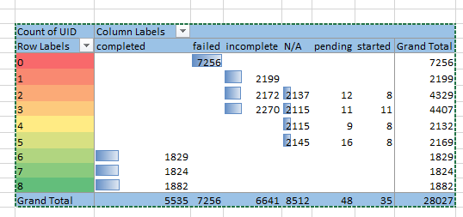

On average we can see that the ratings captured shows the high value and high satisfaction rate when the session was completed.

**7.** How should the call center balance the workload among agents to ensure optimal performance and avoid burnout? Mention your approach and spreadsheet function for the answer.

Ans: To approach this to either manage or balance the workload among agents.

**Call Distribution vs Hours**

**2000**

**1855 1875**

**1664 1673 1704**

**1472 1591 1574**

**1673 1747 1773**

**1500**

**1438**

**1443**

**1153**

**1099**

**1000**

**856**

**912**

**560 553**

**500**

**226 304**

**347 268 267**

**0**

**0 1 2 3 4 5 6 7 8 9 10 11 12 13 14 15 16 17 18 19 20 21 22 23**

**Callers on each day**

**107**

**2024-01-02 196**

**115**

**2023-12-31 158**

**179**

**2023-12-29 258**

**181**

**2023-12-27 242**

**255**

**2023-12-25 258**

**232**

**2023-12-23 241**

**163**

**2023-12-21 159**

**178**

**2023-12-19 209**

**233**

**2023-12-17 185**

**258**

**2023-12-15 276**

**226**

**2023-12-13 348**

**358**

**2023-12-11 424**

**430**

**2023-12-09 288**

**138**

**2023-12-07 254**

**254**

**2023-12-05 253**

**364**

**2023-12-03 383**

**333**

**2023-12-01**

**0 50 100 150 200 250 300 350**

**372**

**400**

**450**

**500**

Total Calls received = 8508 including failed

Total Astro Guru’s = 131 (Count of guru_unique_id)

Total no. of days = 34

Average no. of calls handled by each guru = Total Calls received / Total Astro Guru’s

=8508/131 = 6

Total no. of Call handled by Guru per day = Average no. of calls handled by each guru / Total no. of days = 64.95/34 = 1.92

Round of 1.92 is 2.

On an average the calls handled by Guru per day is 2 approx.

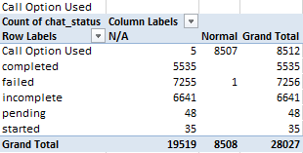

To ensure optimal performance and avoid burnout:

* More agents can be asked to be available during the peak hours by assigning them to shifts to give the sessions accordingly to the users to avoid the incomplete status of the calls or chats.
* Technology can be upgraded by having AI chatbots by providing the services based in the users reply and traffic tools can be used to monitor by assisting the users to schedule the sessions accordingly based on the sessions already booked by the users.
* As we have seen some good ratings provided for the chat sessions company can utilize the services like chatbot which can autoreply or schedule the session based on the slot availability.

**8.**What new technologies or tools could be implemented to enhance call center operations and customer service?

Ans: As we have Web, Dashboard, gurucool and for call service only Exotel is being used as mentioned above.

* Live Streaming can be done weekly to keep the users engage them to the organization
* If Agent is busy instead of avoiding the session it can be carried to another agent who is free at that time to result that session complete
* AI Chatbots can be implemented to the users for the quick suggestions & replies.
* Alternate services like Exotel can be acquired by making this hybrid by having both alternate service and Exotel which can increase robust services by offering features like better integration and by avoiding the traffic within one service.

**9.**What metrics should be included in the final dashboard to comprehensively view call center performance and guide investment decisions?

Ans:

* Chat status(Completed, failure, N/A)
* Call status (completed, busy, failed)
* Source type
* Consultation type.

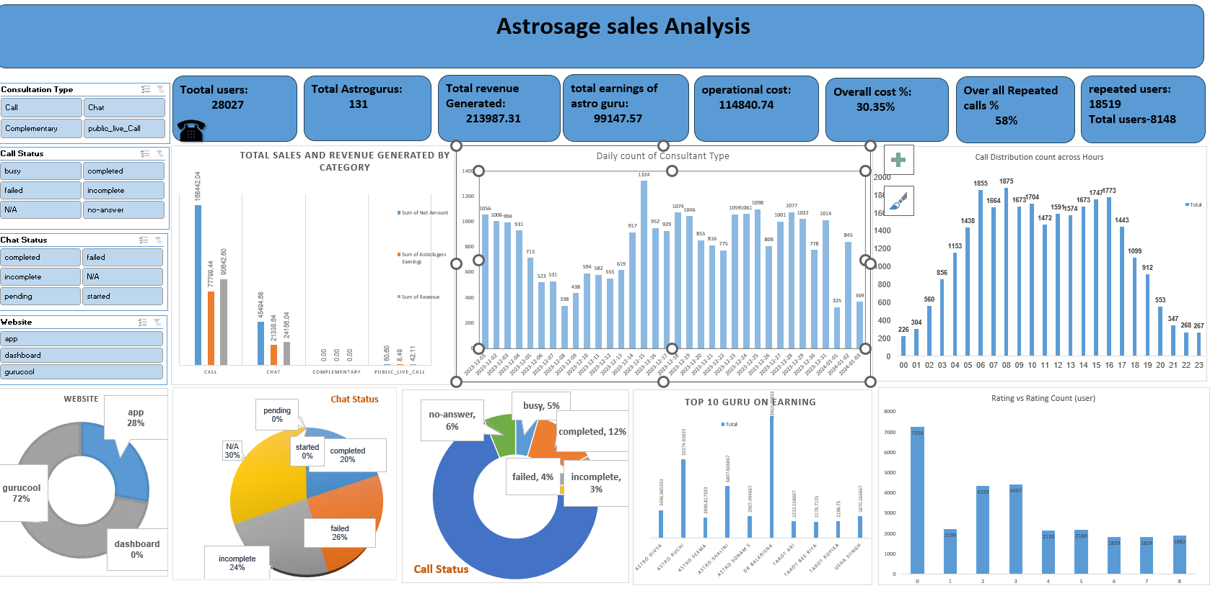

1. **KPI (Key performance indicator)**
   1. Total No. of Users
   2. Total no. of Astro Guru’s (Agents)
   3. Total net revenue
   4. Total Astro Guru’s Earnings
   5. Operation Cost
   6. Overall Call%
   7. Overall Repeated Calls %
   8. Repeated Users & Single Time Users
2. Day vs Users Consulted (Daily)- which shows how many users consulted in a day
3. Source of Contact- shows how many users consulted through gurucool, dashboard, app.
4. Consultation type vs Revenue- It will show the earning behind every consultancy type such as call, chat, public_live_call.
5. Rating vs count of User (User distribution by rating)- This will show the number of users that give specific rating
6. Call distribution vs hours (day)- shows how many users consulted during time
7. Top 10 Astro Guru’s with highest Revenue
8. Slicers Used: Consultation Type (call, chat, public_live_call, complimentary) & call status(completed, busy, failed, incomplete), website.

**10.**How would you allocate a 1 crore rupee investment to optimize operational efficiency, enhance customer satisfaction, and boost profitability, and what analysis-based recommendations would you offer to support this?

[you have to give bullet pointers to answer this question]

Ans:

* Training & Hiring New agents which will eventually help the existing agents by improving their knowledge to deliver more good services to existing users in sessions and will help in getting new users to organization which will have the impact on the Revenue generation. Though ROI will impact but we can retain the existing agents by adding some incentives, bonus and bond period
* Technology & Upgrading- We can upgrade the technology and adding the alternative services like call type which will help the users to connect with agents by avoiding the failure or busy scenarios.
* Marketing- We can start promoting our organization by giving some offers like discounts, and conducting live session for free on weekends, advertising in malls, premium membership with complimentary sessions, discounts for upcoming sessions post completing one or two sessions.

**Thank you.**